**Customer Tutorial Gr-resQ tool + OSCM**

**Author:** Ricardo Toro

**Version:** 1.0.0

**Date:** 08/02/2019

**Description:**

This tutorial will guide you on the process of creating and managing a transaction (experiment) using the Gr-reQ tool and the OSCM platform. This tutorial is from the customer perspective.

A customer is the person who is willing to create a transaction or experiment to be run in a CVD furnace. The transaction will be shared to the provider, who is going to execute the experiment in the CVD furnace. All results coming from the experiment will be attached to the transaction, so the customer could use them for further analysis.

**Workflow:**

1. Create an OSCM account.
2. Request access to the provider of a CDV facility to create transactions.
3. Create a recipe.
4. Create a transaction (experiment) and attach the recipe.
5. Wait until the provider complete a transaction and attach results.
6. Download results and run further analysis.

**Steps:**

1. Create an OSCM account:

There are two ways of creating an OSCM account: a) from the official OSCM website (<https://oscm-il.mechse.illinois.edu/>) or b) using the Gr-resQ tool.

a) From OSCM:

* Open your Chrome browser and go to <https://oscm-il.mechse.illinois.edu/>
* Click on **Register** button.
* Fill in all required information. The only field that you do not need to fill out is the **“User Accounts”** field.
* To verify your new user account, access your email mailbox (the one that you provided when registering).
* Find the email sent by OSCM in your mailbox. Click on the provided link. Then, you are all set.

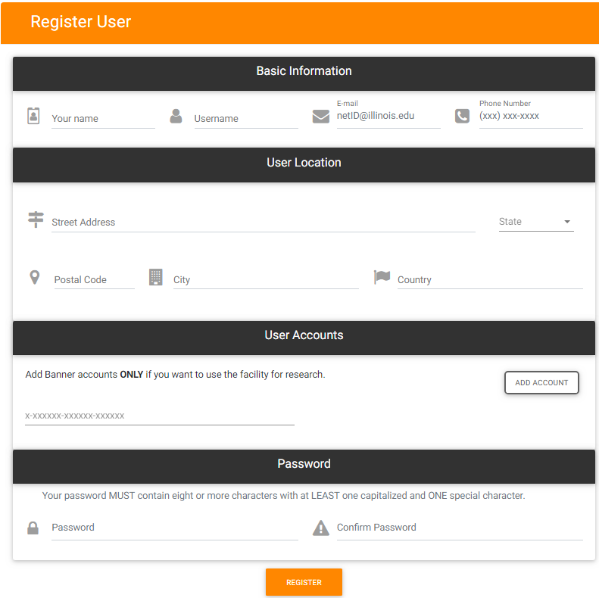

Figure 1: User registration from OSCM website

b) From Gr-resQ tool:

* Open the Gr-resQ tool.
* Click on **OSCM** tab. Then click on **Register** button.
* Fill in all required information. Then, click on **Submit** button.

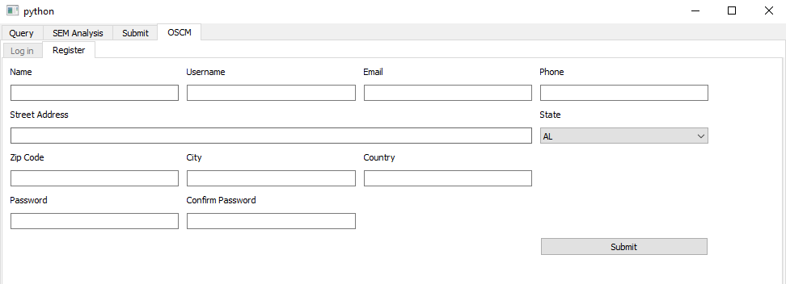

Figure 2: User registration from Gr-resQ tool

* To verify your new user account, access your email mailbox (the one that you provided when registering).
* Find the email sent by OSCM in your mailbox. Click on the provided link. Then, you are all set.

1. Request access to the provider of a CDV facility to create transactions:

There are two ways of requesting access from a provider: a) from the official OSCM website (<https://oscm-il.mechse.illinois.edu/>) or b) contacting the provider directly.

a) From OSCM:

* Open your Chrome browser and go to <https://oscm-il.mechse.illinois.edu/>
* Log in with your OSCM credentials.
* In the **BOOK TIME** tab, find the facility that you want to get access to. Use the two arrows to find more facilities. Click on **Learn more**.

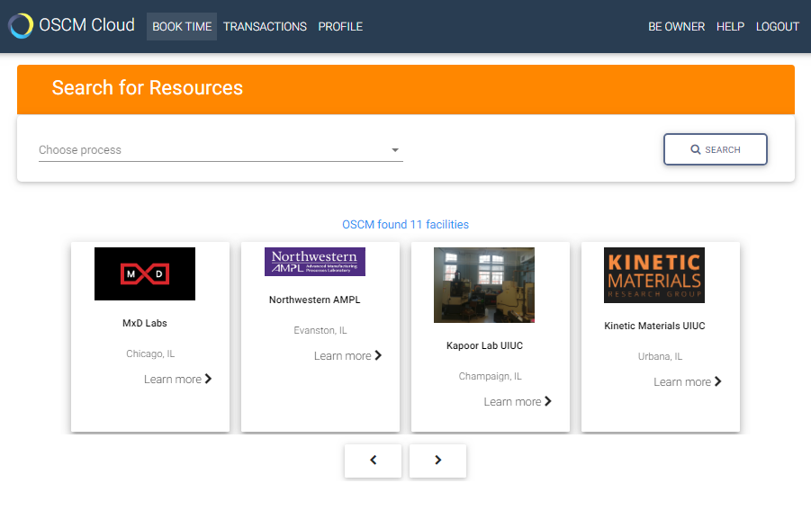

Figure 3: Find facility

* Click on **REQUEST ACCESS** button. Wait until the provider gives you access to the facility.

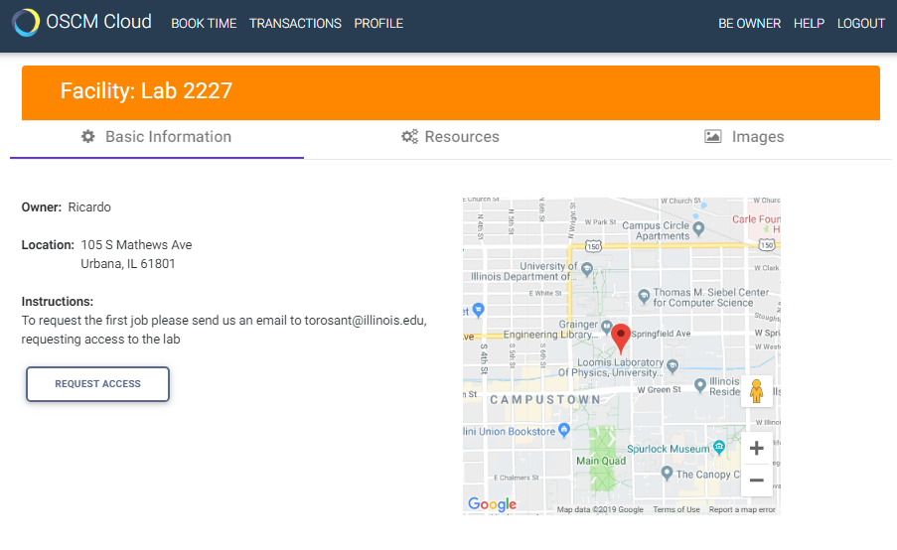

Figure 4: Request access

b) Contact the provider directly:

* Send the provider an email with your OSCM **username** requesting access to the facility.

1. Create a recipe:

* Open the Gr-resQ tool.
* Go to **Submit** tab.
* Click on **Add Step** button and fill in all fields. Keep adding more steps by clicking on **Add step** button.
* Once the entire recipe is documented, click on **Submit to OSCM** button. This will automatically take you to the **OSCM** tab.

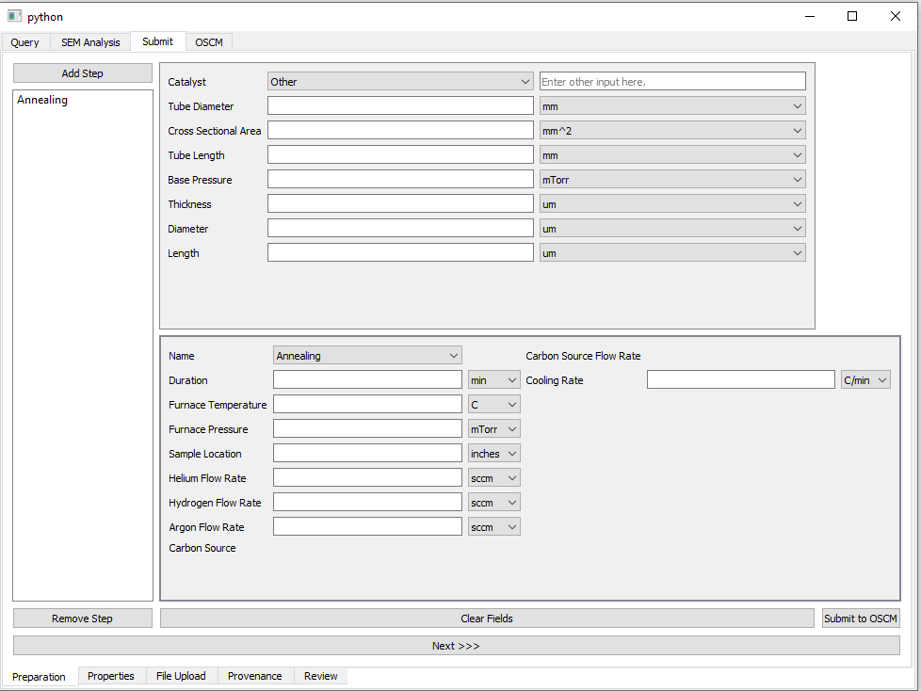

Figure 5: Create recipe

1. Create a transaction (experiment) and attach the recipe:

* Login into **OSCM** with your OSCM credentials.

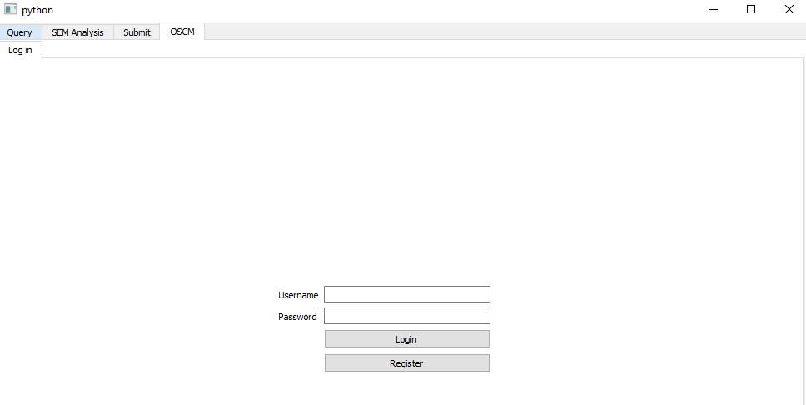

Figure 6: Login into OSCM (Use OSCM credentials)

* Fill in the transaction name (experiment name), the quantity, select the facility that you want the experiment to be done, select the queue, provide more details in the instructions field, and check the recipe.json box. To send the transaction to OSCM click on the **Submit** button.

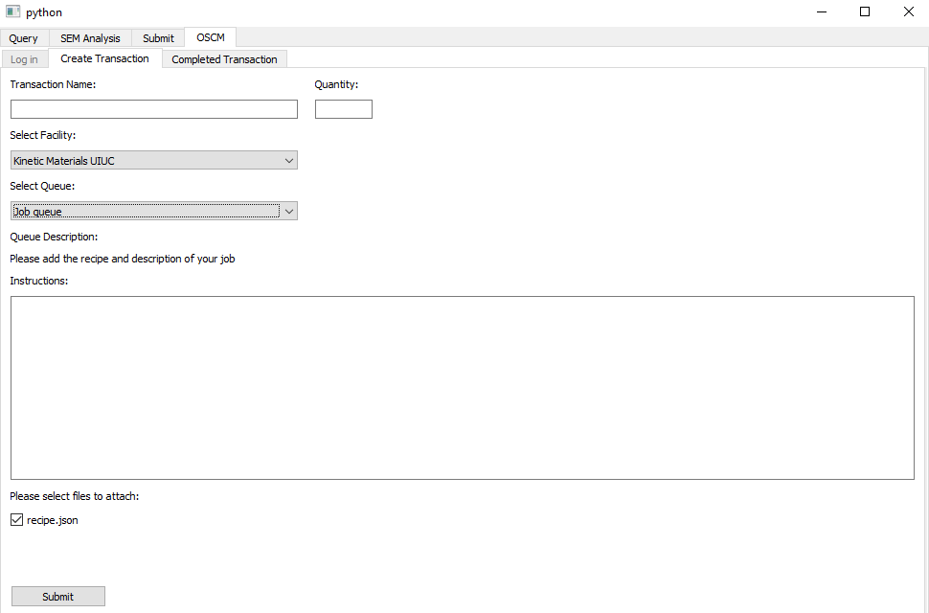

Figure 7: Create transaction (experiment)

1. Wait until the provider complete a transaction and attach results:
   * The user will receive an email once the transaction is created and every time the transaction changes its status. The possible status are: requested, accepted, in progress, completed, declined or cancelled. This means that once the user receives an email with a transaction status of completed, the user can access to the Gr-resQ tool to fetch all transaction (experiment) data.
2. Download results and run further analysis:
   * Open the Gr-resQ tool.
   * Click on the **OSCM** tab.
   * Login with the OSCM credentials.
   * Go to **Completed transaction** tab.
   * Select the transaction that you want to pull data from, and verify all transaction data.
   * Download zip files by clicking **Download Files** button.

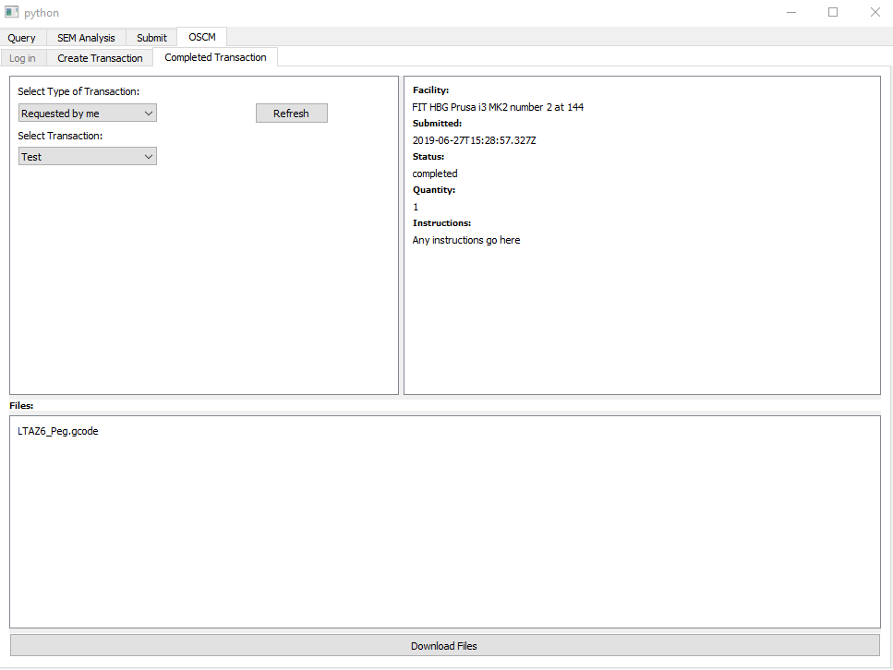

Figure 8: Download all files attached to the transaction